# Interim exam #1

Mikko Karkkainen

## 1.

Bernoulli’s equation:

$$\int_{P_{1}}^{P_{2}}{\frac{dP}{ρ}}+\left[\frac{{\overline{V}}_{2}^{2}}{2β_{2}}- \frac{{\overline{V}}_{1}^{2}}{2β_{1}} \right]+gΔz+E_{f}= 0$$

Assuming $P_{1}-P_{2}=0 , {\overline{V}}_{2}≫{\overline{V}}_{1}$ we get

$$\frac{{\overline{V}}_{2}^{2}}{2β_{2}}+gΔz+E_{f}= 0$$

Assuming friction loss only due to contraction and tube walls:

$$E_{f}=\frac{1}{2}e_{f}{\overline{V}}_{2}^{2}+\frac{2fL}{D}{\overline{V}}_{2}^{2}$$

$$=\left(\frac{1}{2}e_{f}+\frac{2fL}{D}\right){\overline{V}}_{2}^{2}$$

$$\frac{{\overline{V}}_{2}^{2}}{2}\left(\frac{1}{β_{2}}+e_{f}+\frac{4fL}{D}\right)+gΔz=0$$

Velocity in tube:

$${\overline{V}}_{2}={\left(\frac{1}{β_{2}}+e_{f}+\frac{4fL}{D}\right)}^{-\frac{1}{2}}\sqrt{2gh}$$

$${C_{D}=\left(\frac{1}{β_{2}}+e_{f}+\frac{4fL}{D}\right)}^{-\frac{1}{2}}$$

Let’s estimate the Reynolds number by assuming maximum discharge coefficient $C_{D}=1$ and $Δz=3.2 m$:

$${\overline{V}}_{2}=\sqrt{2gh}={\left(2⋅9.8⋅3.2\right)}^{\frac{1}{2} }=7.92\frac{m}{s}$$

$$Re=\frac{D{\overline{V}}_{2}ρ}{μ}=\frac{\left(0.1m⋅7.92\frac{m}{s}⋅7000\frac{kg}{m^{3}}\right)}{0.003\frac{kg}{s*m}}= 1.85⋅{10}^{6}$$

Flow is turbulent, $β_{2}=1$

From the figures below, let’s estimate total friction loss coefficient assuming a smooth pipe:

$$f=0.0025$$

$$\frac{A_{2}}{A_{1}}=\frac{D_{2}^{2}}{D_{1}^{2}}=1.11⋅{10}^{-3}$$

$$e_{f}=0.4$$

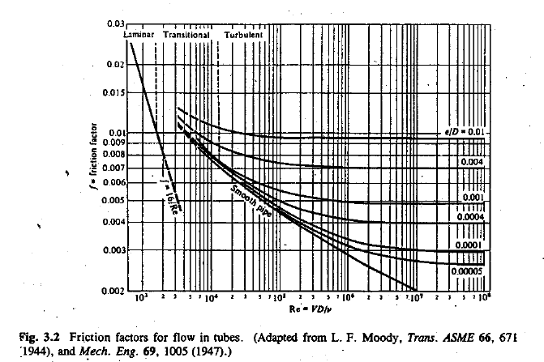

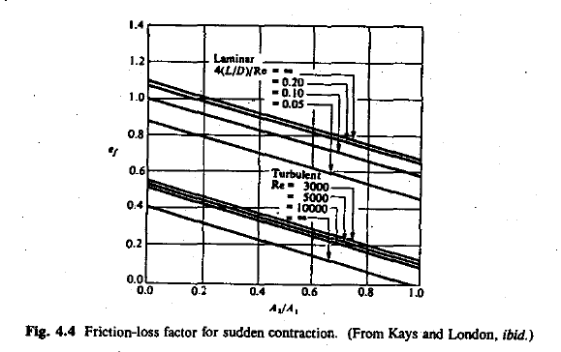

$$4f\left(\frac{L}{D}\right)=2⋅0.0025⋅\left(\frac{0.2}{0.1}\right) =0.02$$

Discharge coefficient :

$${C_{D}=\left(\frac{1}{β_{2}}+e_{f}+\frac{4fL}{D}\right)}^{-\frac{1}{2}}={\left(1+0.4+0.02\right)}^{-\frac{1}{2}}=0.839$$

Checking $C_{D}$ when ladle is empty (5mm remains) :

$${\overline{V}}_{2}={\left(2⋅9.8⋅0.005\right)}^{1/2}=0.313$$

$$Re=\frac{\left(0.1m⋅0.313\frac{m}{s}⋅7000\frac{kg}{m^{3}}\right)}{0.003\frac{kg}{s*m}}=73000$$

Still turbulent, $β_{2}=1$

$$f=0.005$$

$$4f\left(\frac{L}{D}\right)=4⋅0.005⋅\left(\frac{0.2}{0.1}\right) =0.04$$

$$e_{f}=0.5$$

$${C_{D}=\left(\frac{1}{β_{2}}+e_{f}+\frac{4fL}{D}\right)}^{-\frac{1}{2}}={\left(1+0.5+0.04\right)}^{-\frac{1}{2}}=0.806$$

$$\frac{0.806}{0.839}=96.1 \%$$

4% drop in value of $C_{D}$

It may be reasonable to assume that $C_{D}$ is constant.

$$t_{f}=\frac{2{\left(\frac{D_{L}}{D_{N}}\right)}^{2}}{C_{D}}{\left[\frac{h_{0}}{2g}\right]}^{\frac{1}{2}}=2⋅\frac{{\left(\frac{3}{0.1}\right)}^{2}}{0.839}⋅{\left[\frac{3.2}{2⋅9.8}\right]}^{\frac{1}{2}} =867 s$$

Velocity calculated using $C_{D}=0.839:$

$${\overline{V}}_{2}=C_{D}\sqrt{2gh}=0.839⋅{\left(2⋅9.8⋅3.2\right)}^{\frac{1}{2} }=6.64\frac{m}{s}$$

Initial discharge rate:

$$\frac{dw}{dt}=A⋅ρ{\overline{V}}_{2}=\frac{π⋅{\left(0.1 m\right)}^{2}}{4}⋅7000\frac{kg}{m^{3}}⋅6.64\frac{m}{s}= 365\frac{kg}{s}$$

Using the Blasius solution to estimate velocity boundary layer for turbulent flow:

$$δ=\frac{0.385x}{Re^{0.2}}=\frac{0.385⋅0.2 m}{{\left(1.8⋅{10}^{6}\right)}^{\frac{1}{5}} }=0.00432 m$$

However, this equation was developed for flow over flat surfaces and may not work for tubes.

The methodology for calculating the velocity and mass flow assumes the following:

1. Pressure drop only caused by tube and contraction (friction in ladle ignored)
2. Velocity of liquid in ladle ignored
3. It is assumed that $P_{1}=P_{2}$
4. Tube is smooth

The flow rate is overestimated due to these factors.

## 2.

$$δ$$

$$δ_{T}$$

Flow direction

Grashof number:

$$Gr_{L}=g\frac{L^{3}ρ_{f}^{2}β_{f}\left(T_{0}-T_{∞}\right)}{μ_{f}^{2}}$$

Prandtl number:

$$\operatorname{Pr}{=\frac{C_{p}μ_{f}}{k_{f}}}$$

Characteristic length for cylinder:

$$L=\frac{πD}{2}$$

Using $D=3 m$:

$$Gr_{L}=9.8\frac{m}{s^{2}}⋅\frac{{\left(\frac{π⋅3m}{2}\right)}^{3}⋅{\left(7000\frac{kg}{m^{3}}\right)}^{2}{10}^{-5} K^{-1}⋅50K}{{\left(0.003\frac{kg}{s⋅m}\right)}^{2}}=2.79⋅{10}^{12}$$

$$Pr=750\frac{J}{kg⋅K}⋅\frac{0.003\frac{kg}{s⋅m}}{25\frac{W}{m⋅K}}=0.09$$

$$Gr_{L}Pr=0.09⋅2.79⋅{10}^{12}=2.511⋅{10}^{11}$$

The flow is likely turbulent.

To calculate the average heat transfer coefficient, we can use the expression for liquid metals:

$$Nu_{L}=0.936⋅{\left(\frac{Gr_{L}⋅P r^{2}}{4}\right)}^{\frac{1}{4}}=0.936⋅{\left(\frac{2.511⋅{10}^{11}⋅{0.09}^{2}}{4}\right)}^{\frac{1}{4}}=140.5$$

$$h=\frac{Nu_{L}k}{L}=140.5⋅\frac{25\frac{W}{m⋅K}}{\frac{π⋅3m}{2}}=745\frac{W}{m^{2}K}$$

However, using this equation is suspect because it is meant to be used in the range

$${10}^{4}<Gr_{L}Pr<{10}^{10}$$

We had $Gr_{L}Pr=2.511⋅{10}^{11}$

The temperature of the first metal drained from the ladle will be colder than the average temperature, since the downward flowing colder boundary layer will supply the tube enough liquid metal to match the flowrate out of the ladle.

## 3.

2 phases:

1. Before liquid reaches gating system level
2. After liquid reaches gating system level

Let’s ignore time it takes to fill gating system.

Simplified Bernoulli:

$${\overline{V}}_{2}=C_{D}\sqrt{2gh}$$

For Discharge coefficient, let’s use the value calculated in part 1 (ignoring friction of gating system):

$$C_{D}=0.839$$

We need to find the average velocity for the first phase. We can assume linear interpolation.

Change of ladle liquid height when casting is filled up to gates:

$$\frac{π⋅3^{2}}{4}Δz=\frac{π⋅2^{2}}{4}⋅1$$

$$Δz=0.44 m$$

The initial height for the system:

$$h_{1}=4.2 m$$

When filled up to gates:

$$h_{2}=4.2 m-0.44 m=3.76 m$$

First phase average velocity:

$${\overline{V}}_{ave}=\frac{C_{D}\left(\sqrt{2gh_{1}}+\sqrt{2gh_{2}}\right)}{2}=0.839⋅\frac{\left(\sqrt{2⋅9.8⋅4.2}+\sqrt{2⋅9.8⋅3.76}\right)}{2}=7.4\frac{m}{s}$$

Filling time for first phase:

$${\overline{V}}_{2}t⋅\frac{πD_{gate}^{2}}{4}=\frac{π⋅D_{casting}^{2}}{4}⋅h_{casting}$$

$$7.4\frac{m}{s}⋅t⋅π⋅\frac{{0.1}^{2}}{4}=\frac{π⋅2^{2}}{4}⋅1$$

$$t_{1}=54 s$$

For second phase, we must account for the height and change of height of liquid level in the casting:

The final level of liquid in the ladle:

$$\frac{π⋅3^{2}}{4}Δz=\frac{π⋅2^{2}}{4}⋅2$$

$$h_{3}=4.2-0.889=3.31 m$$

$$h=f(t)$$

Velocity at which casting height increases:

$${\overline{V}}_{3}={\overline{V}}_{2}\left(\frac{A_{gating}}{A_{casting}} \right)=\overline{V_{2}}{\left(\frac{D_{gating}}{D_{casting}}\right)}^{2}$$

Velocity at which height of liquid pool in ladle decreases:

$$\overline{V_{1}}=\overline{V_{2}}{\left(\frac{D_{gating}}{D_{ladle}}\right)}^{2}$$

Equation for height evolution:

$$dh={(\overline{V}}_{3}-\overline{V_{1}})dt=\overline{V_{2}} \left({\left(\frac{D_{gating}}{D_{casting}}\right)}^{2}-{\left(\frac{D_{gating}}{D_{ladle}}\right)}^{2}\right) dt$$

Velocity is also a function of height:

$$dh={(\overline{V}}_{3}-\overline{V_{1}})dt= C_{D}\sqrt{2gh}\left({\left(\frac{D_{gating}}{D_{casting}}\right)}^{2}-{\left(\frac{D_{gating}}{D_{ladle}}\right)}^{2}\right) dt$$

$$\frac{dh}{\sqrt{2gh}}=C_{D}\left({\left(\frac{D_{gating}}{D_{casting}}\right)}^{2}-{\left(\frac{D_{gating}}{D_{ladle}}\right)}^{2}\right) dt$$

At beginning of second phase:

$$Δz_{1}= 3.76-1=2.76 m$$

At the end of second phase:

$$Δz_{2}=3.31-2=1.31 m$$

Integrating both sides:

$$\int_{2.76}^{1.31}{\frac{dh}{\sqrt{2⋅9.8⋅h}}}=0.839⋅\left({\left(\frac{0.1}{3}\right)}^{2}-{\left(\frac{0.1}{2}\right)}^{2}\right)t=-0.001165 t$$

Calculated using a computer:

$$-0.233454=-0.001165 t$$

$$t_{2}=-\frac{-0.233454}{-0.001165}=200.4 s$$

Total time:

$$t_{1}+t_{2}=46.4 s+200.4 s≈250 s$$

## Problem 2.

First we calculate the Reynold’s number given the flow rate. For Reynold’s we need the velocity:

$$Re=\frac{D{\overline{V}}_{2}ρ}{μ}=0.01 m⋅\frac{Q⋅1000\frac{kg}{m^{3}}}{A⋅0.001\frac{kg}{s⋅m}}= 0.01 m⋅\frac{Q⋅1000\frac{kg}{m^{3}}}{π⋅\frac{{\left(0.01 m\right)}^{2}}{4}⋅0.001\frac{kg}{s⋅m}}=1.3⋅{10}^{8}\frac{s}{m^{3}}Q$$

After we have Reynold’s number, we can read the friction factor $f$ from the chart below.



After this, we can calculate the pressure drop from equation:

$$\frac{ΔP}{L}=4f\left(\frac{L}{D}\right)\left(\frac{1}{2}\right)ρ{\overline{V}}^{2}=\frac{4fρ{\overline{V}}^{2}}{2D}=2f⋅\frac{\frac{1000kg}{m^{3}}⋅{\left(\frac{Q}{π⋅\frac{{\left(0.01 m\right)}^{2}}{4}}\right)}^{2}}{0.01 m}=fQ^{2}⋅2.55⋅{10}^{9}\frac{kg}{m^{8}}$$

For Flow rates:

|  |  |  |  |
| --- | --- | --- | --- |
| $$Q$$ | $$Re= 1.3⋅{10}^{8}\frac{s}{m^{3}}Q$$ | $$f$$ | $$\frac{ΔP}{L}=fQ^{2}⋅2.55⋅{10}^{9}\frac{kg}{m^{8}}$$ |
| $${10}^{-6}\frac{m^{3}}{s}$$ | $$130$$ | 0.123 | $$3.137⋅{10}^{-4}\frac{kg}{m^{2}s^{2}}$$ |
| $${10}^{-5}\frac{m^{3}}{s}$$ | $$1300$$ | 0.0123 | $$3.137⋅{10}^{-3}\frac{kg}{m^{2}s^{2}}$$ |
| $${10}^{-4}\frac{m^{3}}{s}$$ | $$13000$$ | 0.0043 | $$0.1097 \frac{kg}{m^{2}s^{2}}$$ |

There is a qualitative difference between ${10}^{-4}\frac{m^{3}}{s}$ and ${10}^{-5}\frac{m^{3}}{s}$, because the flow changes from laminar to turbulent.

## Problem 3.

Phase 1: Cool to $T_{s}$

$$\frac{T_{m}-T_{f}}{T_{i}-T_{f}}=\exp\left(-\frac{hAt_{1}}{ρc_{p}V}\right)$$

$$t_{1}=-\frac{ρc_{p}V}{hA}\ln\left(\frac{T_{m}-T_{f}}{T_{i}-T_{f}}\right)=\frac{\left(-8900\frac{kg}{m^{3}}⋅700\frac{J}{kg⋅K}⋅100⋅{10}^{-6} m\right)}{1000\frac{W}{m^{2}⋅K}⋅6}\ln\left(\frac{1000 K-293 K}{1800 K-293 K}\right)$$

$$t_{1}=0.0786 s$$

Phase 2: solidification

$$t_{S}=\frac{mH_{f}}{hA\left(T_{m}-T_{f}\right)}=\frac{\left(\frac{\frac{4}{3}π⋅{\left(100⋅{10}^{-6}m\right)}^{3}}{8}⋅8900\frac{kg}{m^{3}}⋅3⋅\frac{{10}^{5}J}{kg}\right)}{1000\frac{W}{m^{2}⋅K}⋅\frac{4π⋅{\left(100⋅{10}^{-6}m\right)}^{2}}{4}⋅\left(1000 K-293 K\right)}=0.06294 s$$

Phase 3: Cool solid to 300 K

$$t_{3}=\frac{\left(-8900\frac{kg}{m^{3}}⋅700\frac{J}{kg⋅K}⋅100⋅{10}^{-6} m\right)}{1000\frac{W}{m^{2}⋅K}⋅6}\ln\left(\frac{300 K-293 K}{1000 K-293 K}\right)=0.4792 s$$

Total time:

$$t_{1}+t_{s}+t_{3}=0.0786 s+0.06294 s+0.4792 s=0.621 s$$

Assuming Newtonian cooling:

$$\frac{dT}{dt}=-\frac{hA\left(T-T_{f}\right)}{VρC_{p}}=-\frac{\left(1000\frac{W}{m^{2}⋅K}⋅6\right)}{\left(8900\frac{kg}{m^{3}}⋅700\frac{J}{kg⋅K}⋅100⋅{10}^{-6} m\right)}\left(1000 K -293 K\right)= -6809\frac{K}{s}$$

## Problem 4

Critical cooling rate:

$\frac{dT}{dt}=100\frac{K}{s}$ at $T=600 K$

$$T_{P}-T_{∞}=\left(\frac{QV}{2πkαe}\right)\left(\frac{1}{2+Pe_{r}^{2}}\right)$$

$$Pe_{r}=\sqrt{\frac{QV}{2πkαe\left(T_{p}-T_{∞}\right)}-2}=\sqrt{\frac{2000 W⋅0.5\frac{m}{s}}{2⋅π⋅35\frac{W}{m⋅K}⋅7.2⋅{10}^{-6}\frac{m^{2}}{s}⋅e⋅\left(1100 K-300 K\right)}-2}$$

$$Pe_{r}=16.98$$

$$Pe_{r}=\frac{Vr}{2α}$$

$$r=\frac{2αPe_{r}}{V}=2⋅7.2⋅\frac{{10}^{-6}m^{2}}{s}⋅\frac{16.98}{0.5\frac{m}{s}}=4.89⋅{10}^{-4} m$$

It’s possible to harden up to approximately $0.5$ mm

Using code example in solution manual:

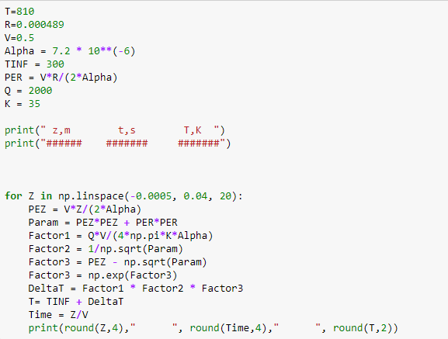

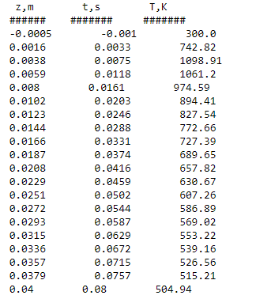

$$\frac{dT}{dt}=\frac{586.89-607.26}{0.544-0.502}=-485\frac{K}{s}$$